   
  
  
  
  
  
  
  
  
  
  
  
American International University-Bangladesh (AIUB)  
**Department of Computer Science  
Faculty of Science &Technology (FST)  
Summer 19_20**

**Course: Object Oriented Programming-02**

**Mentor: Victor Stany Rozario**

**Section: G**

**Assignment:**

**“Interface (Basic and Scientific Calculator functionality)”**

**Name: Hossain, Md. Mridul**

**ID: 18-38670-3**

1.Interface -> IBasicCalculator(Addition,Subtraction,Multiplication,Division)

-> IScientificCalculator(XtoY,n!,ConvertToBinary)

2.Class -> BasicCalculator

-> ScientificCalculator

*BasicCalculator will implement IBasicCalculator

*ScientificCalculator will inherit BasicCalculator and implement IScientificCalculator

**Output:**

Basic Calculator Output:

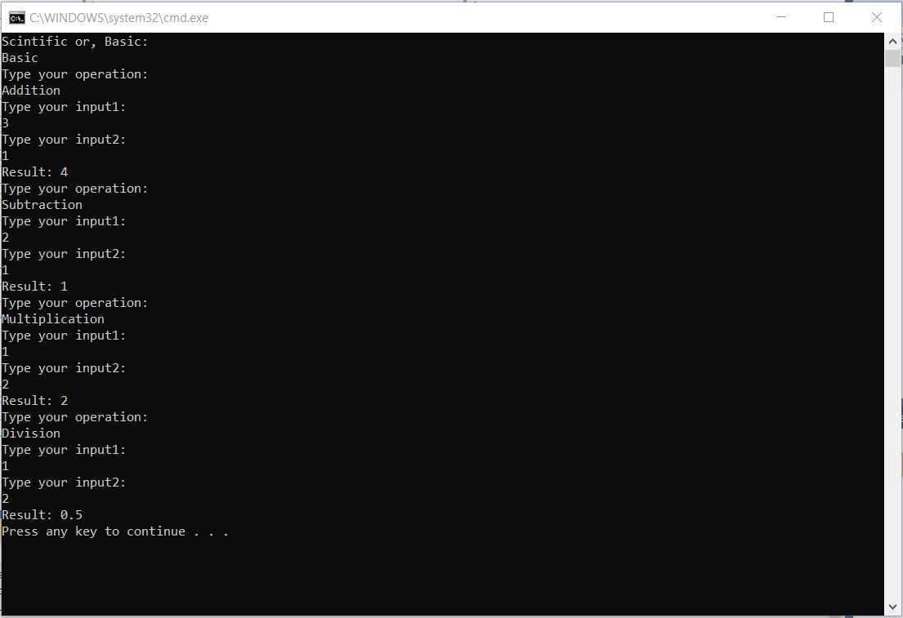

Scientific Calculator Output:

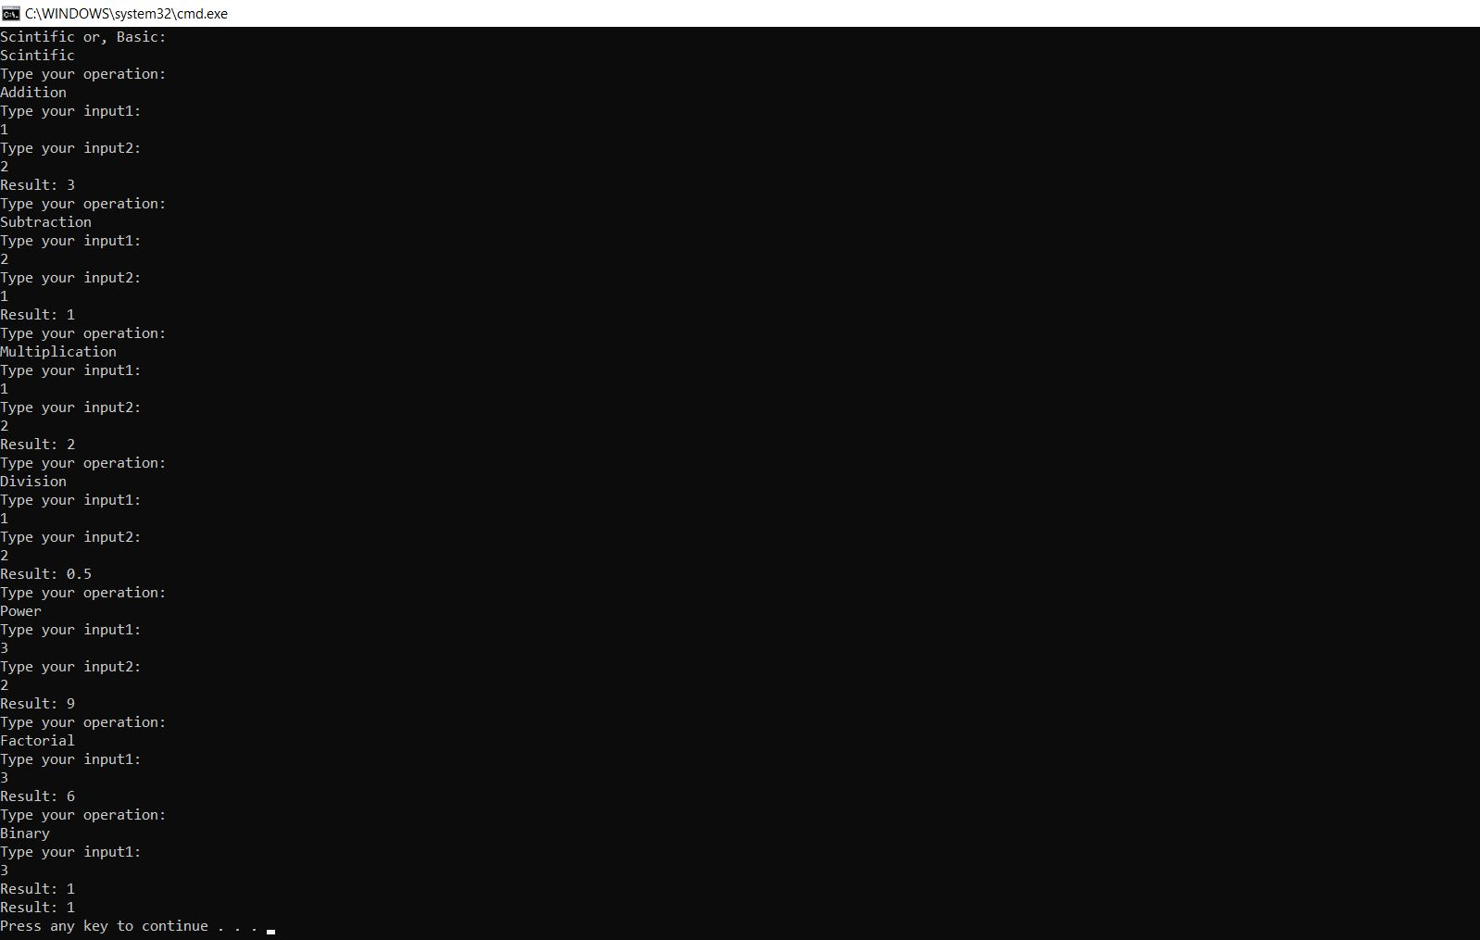

**Source Code:**

Interface(IBasicCalculator & IScientificCalculator-01)

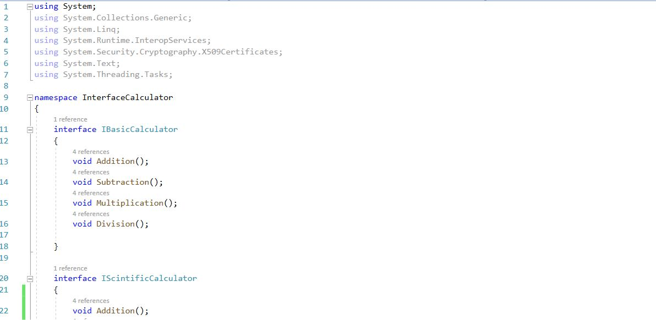

Interface(IScientificCalculator-02) & Class(ScientificCalculator-01):

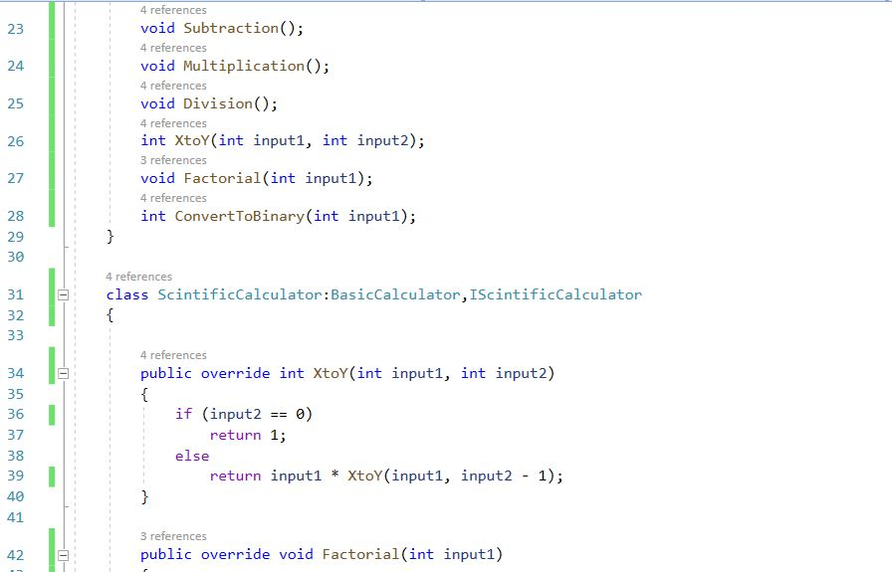

Class(ScientificCalculator-02):

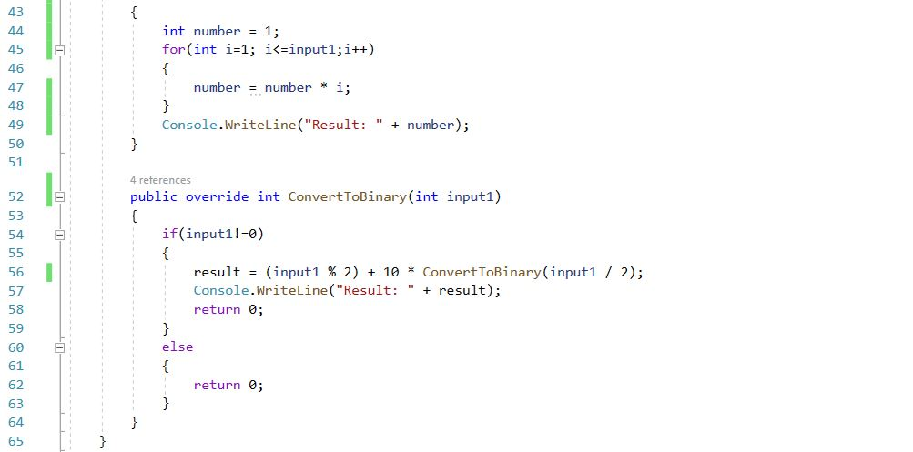

Class(BasicCalculator-01):

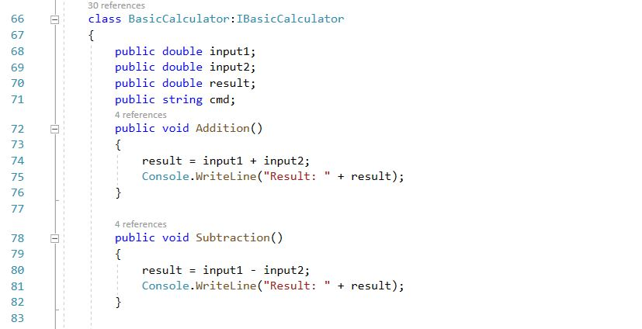

Class(BasicCalculator-02):

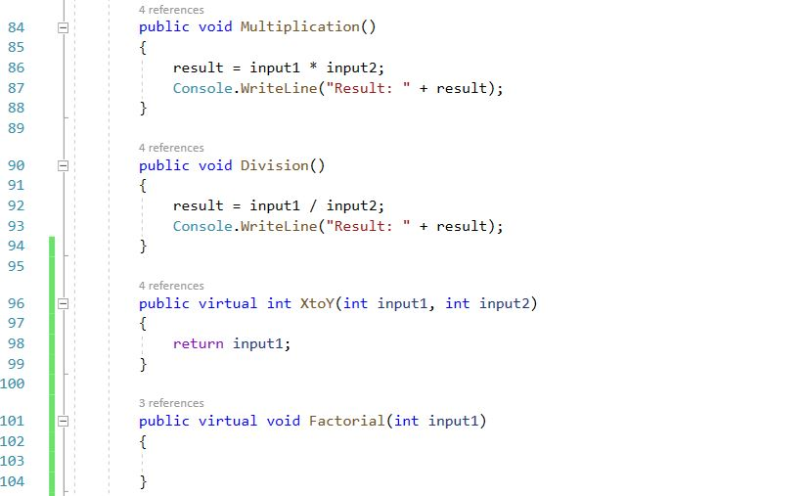

Class(BasicCalculator-03) & Class(Program-01):

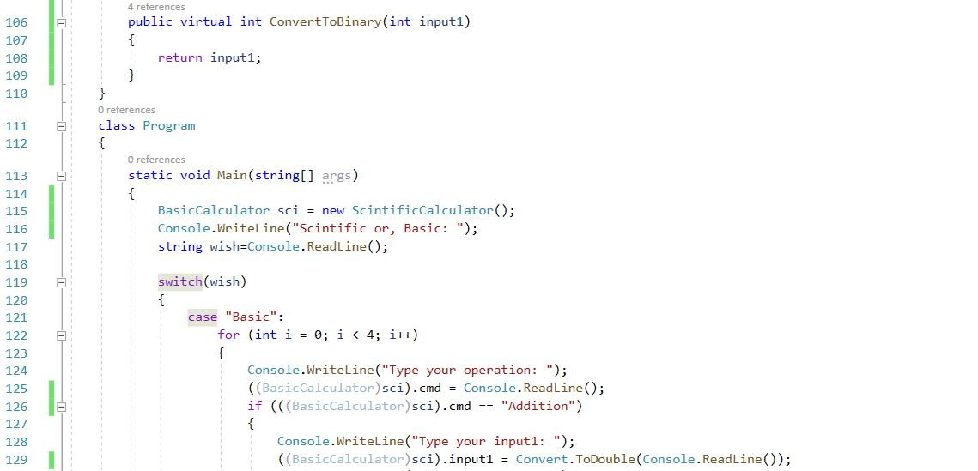

Class(Program-02):

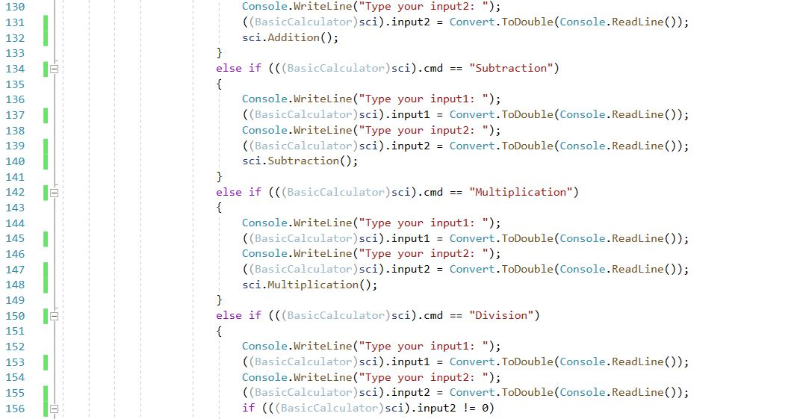

Class(Program-03):

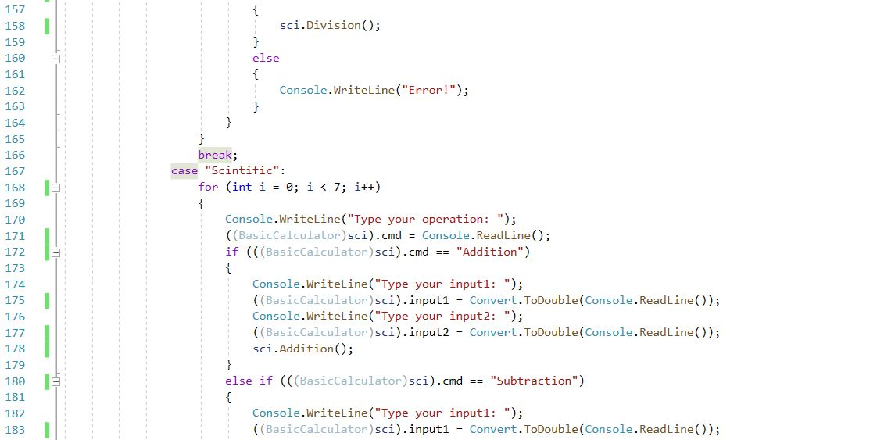

Class(Program-04):

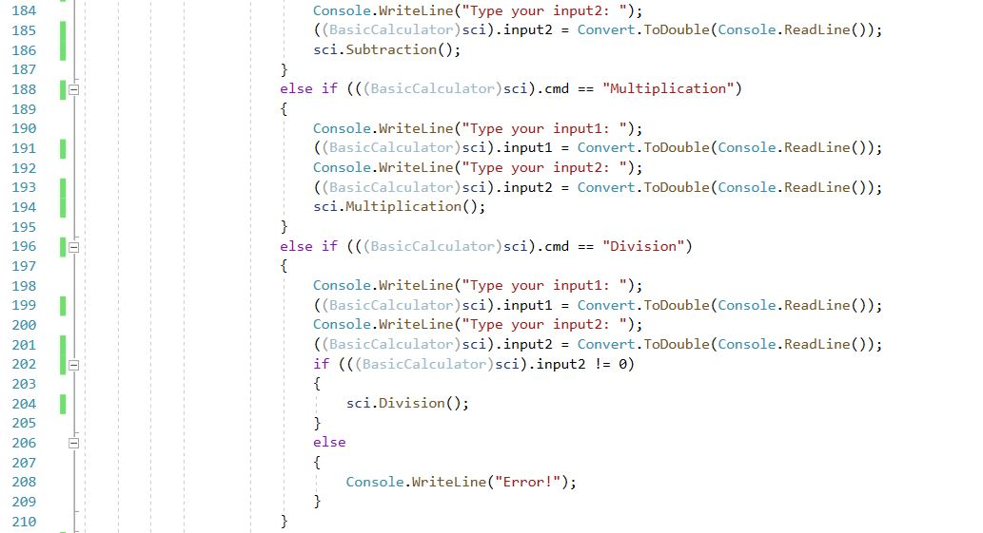

Class(Program-05):

